## L12 HW –Web Form JS Validation

## Professor Navarro

## COP3834 – Web Application Development

### **Background**

Forms in html only offer basic validation tools to prevent mistyped user input from being sent to the back office for storage or processing. In this assignment, you will create a webpage for your fictitious “bottled air” client to capture subscriber data. The bottled air client needs a web page that provides a form. The form will allow users to fill out and subscribe to a monthly plan that delivers air to the client’s home as a paid service.

The page should reflect the business that you are modeling on your top rank seo project but does not need to actually link to it. However, your form page will need a Nav bar (links can be place holders) and be hosted on your aws EC cloud instance. You may use a FQDN or just the url provided by Amazon. The page is primarily just a form, but needs to look professional and suggest it is part of a larger site.

### **Procedure**

1. Create a html page named air-membership-cen.html Replace the cen with your Initials.
2. Create css file dedicated to this page. Place In the css directory. Bootstrap or SASS Is allowed.
3. Create a js file named membershipForm.js In the js directory. This file needs to be called In the <head> section of the html page. All js should go Into this or additional external files.
4. Html page should have business name and nav bar with 3 links. They can hold "#" placeholders for the url. Also Include a footer.
5. Main body of page should contain form that has simple Instructions and labeled form elements. Be sure this Is nested In a unique container.
6. Form elements required:

|  |  |
| --- | --- |
| **Input Type** | **JS Validation** |
| first name | Each word must start with a capital letter, if not JS will convert on submission |
| last name | Each word must start with a capital letter, if not JS will convert on submission |
| phone number | can only contain numbers or numbers and dashes |
| email | email must have a . and @ character with a TLD. There must be at least one character before the and after the @ . There must be at least two characters after the period . |
| password with 6 char minimum | Validate password has 6-9 characters, contains a number and a letter |
| radio button with 3 possible options for different tiers of bottled air subscription (use your imagination) | Check if a radio button is selected |
| select list input with at least 3 options of different air qualities |  |
| Submit button label | Change or add label to let users know data was submitted |
| Submit button type | Use Get (this is not js related). All inputs should be in the query string after validation |
| All | check for empty field on name and email, notify user of which empty field, change background color to focus color |
| Reset button | Reset form elements with button |

1. Create a "setBackground" function that changes the background color of the form element In focus.
2. Create an event handler (addEventListener) using js that listens for submit button to be pressed.
3. Ensure the page (DOM) Is loaded before trying listen for a reference that doesn't exist yet. Wrap the above event handler for the submit button In a DOMContentLoaded event handler
4. Do not use jQuery or js plugins. Write the code yourself.
5. Web page does not have to be responsive. Will test on 1280x720 desktop viewport.
6. Upload code to your ec2. Prevent crawlers from indexing this page. Update your robots.txt file on your EC2 Apache web server. Add name of html file to robots.txt. If It does not exist, then create file with permissions 644.
7. Provide .txt or .doc file with url of hosted file. This can be fully qualified domain name from a registrar or based on the provided name given by Amazon.
8. Zip all web related files together and submit as single zipped directory

# Webpage Screenshots

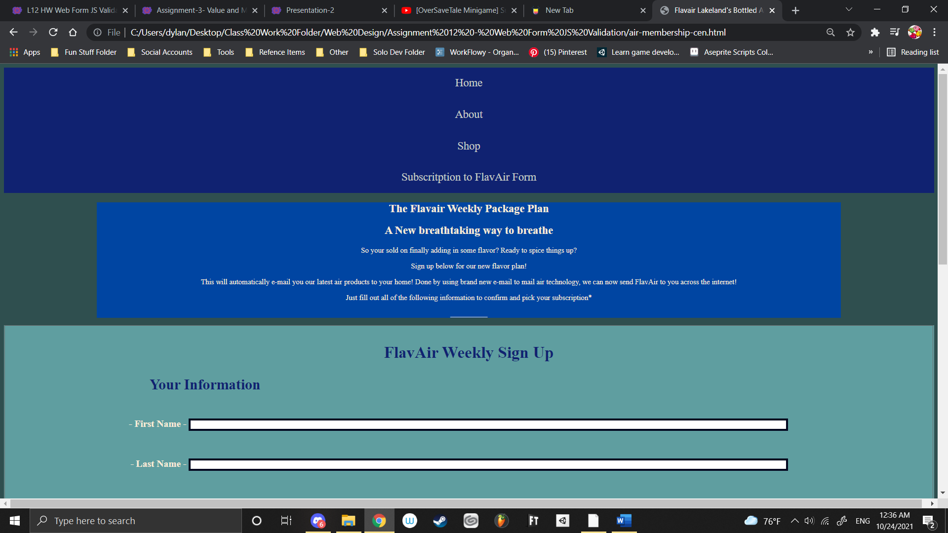

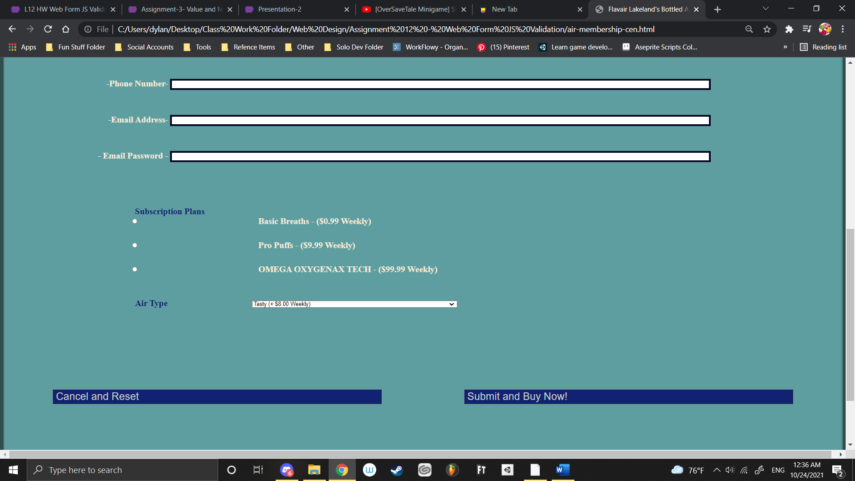

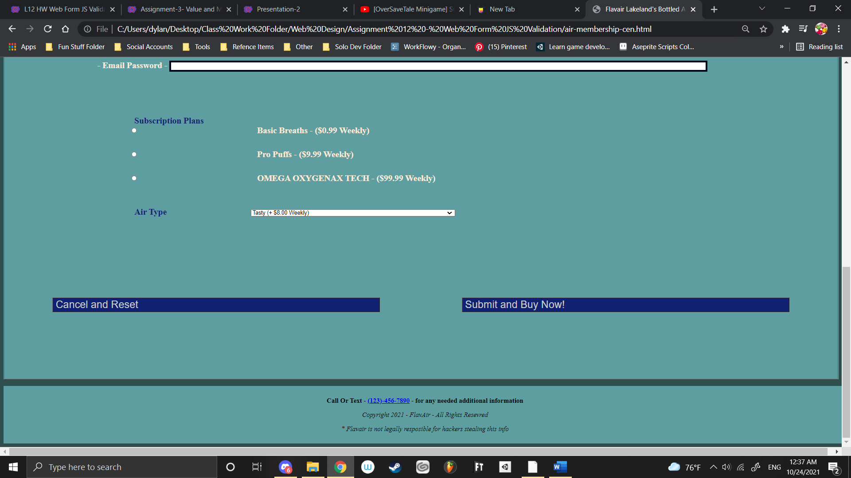

|  |  |
| --- | --- |
| **L12 HW - Web Form JS Validation Rubric** |  |
| **Assessment** | **Points** |
| Submit named air-membership-cen.html, css/membership-style.css, js/ membershipForm.js in a win zipped directory. | 20 |
| Screen shot included of rendered web page as jpg | 5 |
| Html, CSS, JS is easy to read, structured well with appropriate comments. | 15 |
| Evidence file is hosted on Amazon EC2. | 10 |
| Form meets requirements and includes appropriate javascript validation | 30 |
| Appearance: Fonts have good contrast and are easy to read and look professional. Form looks professional and styling is consistent. Appears to be part of a website. | 10 |
| Web page also includes nav bar and footer | 5 |
| Robots.txt correctly updated | 5 |
|  |  |
|  |  |
| Sub total | 100 |
| Extra Credit – Make page responsive and easy to use on iPhone 6 display. | 5 |